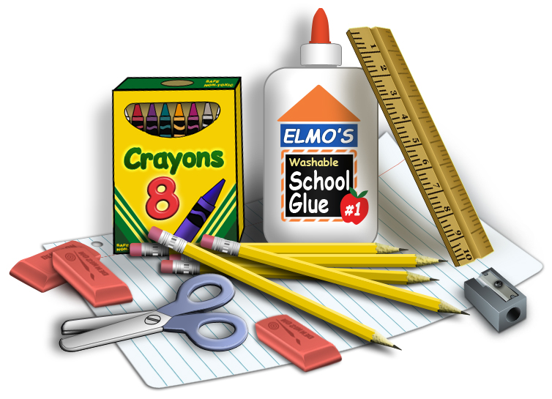First Grade Supply List

\*4 plastic 2-pocket folders – 1 Blue, 1 Green, 1, Red, 1 Yellow

\*4 composition notebooks (not with perforated pages)

\*1 pair of Fiskers blunt end scissors

\*1 plastic pencil box

\* 2 boxes 24 count Crayola crayons

\* 2 boxes 24 count Crayola colored pencils

\* 2 boxes 12 count fat Crayola washable markers

\* 1 box #2 wood pencils

\* 1 box Expo 4 count dry erase markers

\* 1 highlighter marker any color

\* 2 pink erasers

\* 10 fat glue sticks

\* Boys- gallon size Ziplock baggies Girls- quart sized Ziplock baggies

\* 1 pair of overhead headphones that can be used with an iPad

\* 1 re-useable water bottle labeled with your child’s name

\* 1 backpack large enough to hold a folder, lunchbox, water bottle, etc.

Optional: Small items for our treasure box such as matchbox cars, bouncy balls, play jewelry, pencils, erasers, and any other little item that is appropriate. No candy please since we may have allergies or special restrictions.