**1.** What fraction of the whole is shaded? What fraction of the whole is **NOT** shaded?

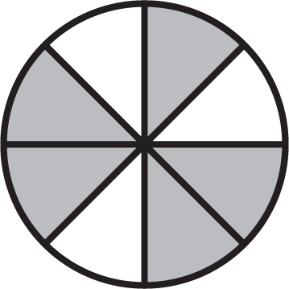

**2.** Write a fraction to name the equal parts of the whole casserole. How many parts would you need to make two whole casseroles? Explain.

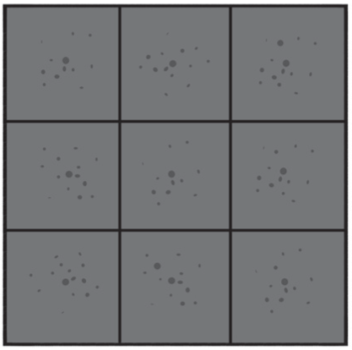

**3.** This line segment represents  of the length of Jo’s desk. Which represents the whole length and has an accurate explanation?

125_03

125_04**A**   
The line segment represents  the distance of Jo's desk. So, the whole distance is 3 times as long.

**B** 125_05   
The line segment represents  the distance of Jo's desk. So, the whole distance is 2 times as long.

**C** 125_06  
The line segment represents  the distance of Jo's desk. So, the whole distance is 4 times as long.

**D** 125_07   
The line segment represents the length of Jo's desk. So, the whole distance is identical to the line segment.

**4.** Which point is  on the number line?

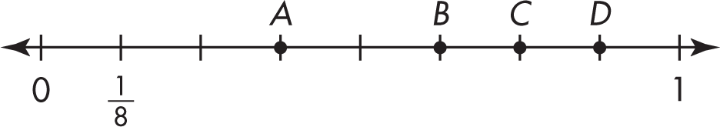

**A** Point *A* **C** Point *C*

**B** Point *B* **D** Point *D*

**5.** Which of the fractions would be to the left of 1 on a number line? Select all that apply.

Description: Untitled-1  Description: Untitled-1 

Description: Untitled-1  Description: Untitled-1 

Description: Untitled-1 

**6. A.** Draw a figure to show .

**B.** Explain how you knew you had shaded the correct parts of your picture.

**7.** In Emily’s bead collection,  of her beads are red and  of her beads are green. What fraction of her beads are **NOT** red? What fraction of her beads are **NOT** green?

**8.** One point on the number line has been marked with the fraction . Write a fraction for each of the other points shown.

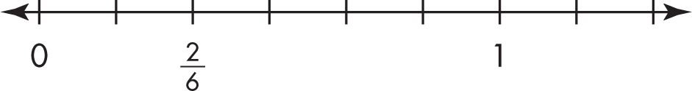

**9.** Explain how you know  represents a whole.

**10.** Marina folded a piece of paper that is 9 inches by 12 inches into sections as shown below. What fraction of the total area is each section? Explain.

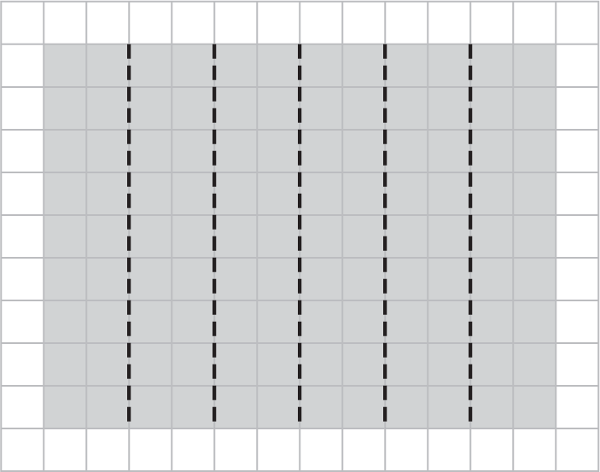

**11.** How many s are in ?

**12.** Mr. Roberts is building a fence with 5 equal parts. He spent 90 minutes working on each of 2 days. On the first day, he built  of the fence. The second day, he built another  of the fence. How many -parts did he build in the first two days?

**A** 1

**B** 2

**C** 3

**D** 4

**13.** How many s do you need to get ? Use the number line below for help.

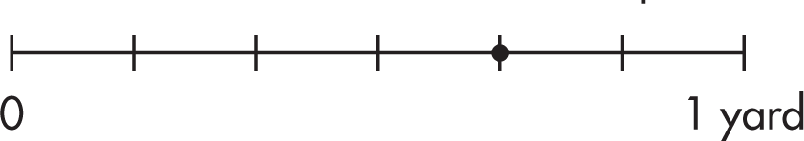

**A** 1

**B** 3

**C** 4

**D** 6

**14.** Which point represents 6 lengths of on the number line? Explain.

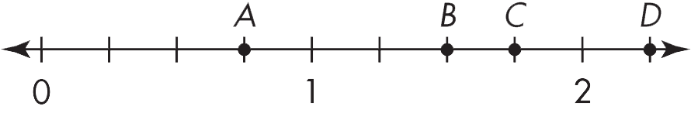

**15.** Divide the rectangle into 6 equal parts. What fraction does each part represent?

**16.** Pauline drew  of a shape below. Draw a picture to show the whole shape and write a fraction to represent the whole.

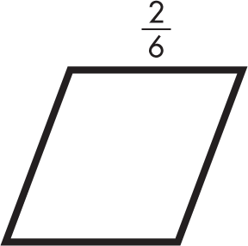

**17.** Li believes that  of the figure is shaded. Is he correct? Explain.



**18.** Select all the sentences that describe this shape.

**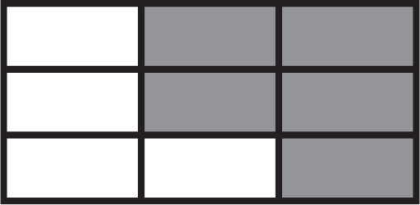**

Description: Untitled-1  of the shape is shaded.

Description: Untitled-1  of the shape is shaded.

Description: Untitled-1  represents the whole.

Description: Untitled-1  of the shape is unshaded.

Description: Untitled-1  of the shape is unshaded.

**19.** Divide the number line into equal lengths. Then mark and label the given fraction.   
8 equal lengths; 

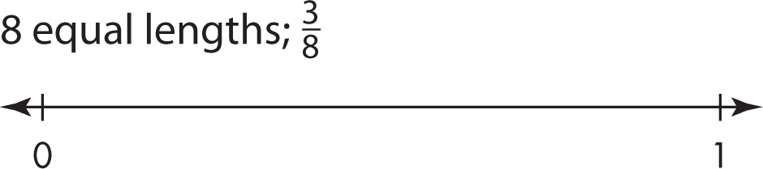

**20.** Mary has a box of colored chalk. The table shows the lengths of some of the pieces of chalk.

|  |  |
| --- | --- |
| **Lengths of Chalk** | |
| **Chalk Color** | **Length (nearest**  **half inch)** |
| Yellow Chalk | 3 in. |
| Blue Chalk | in. |
| Red Chalk | in. |
| Orange Chalk | 3 in. |
| Green Chalk | in. |
| Purple Chalk | 4 in. |

**A.** Measure the lengths of Mary’s gray and white pieces of chalk shown below to the nearest half inch.

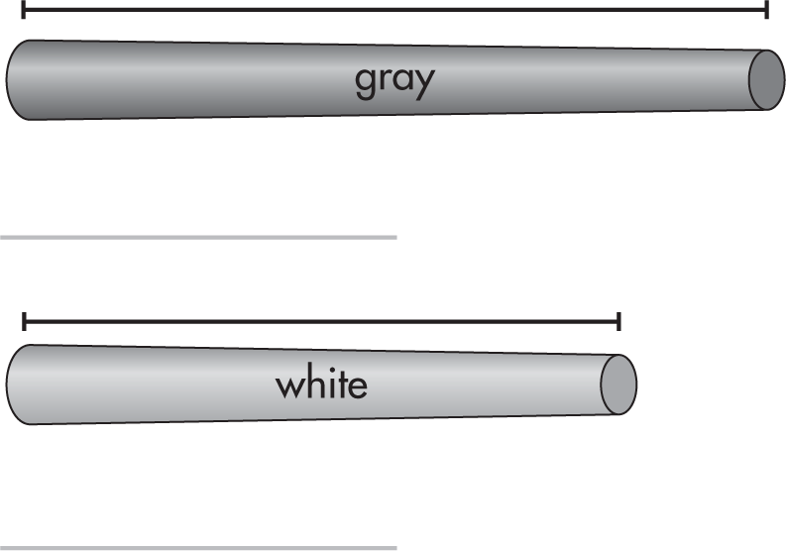

**B.** Draw a line plot to show the lengths of all the pieces of chalk to the nearest half inch.